OPEN SOURCE TECHNOLOGIES (01CE0618)

Lab Manual

Name : Jadav Prince Enrolment No: 92301703126
Class : | 6EC1
Batch : | B

INDEX

Lab | Program | Date | Marks | Signature
1. | Explore GitHub/GitLab for open-source projects with different licenses
2. | Setup Git and explore commands related to Version Control System (VCS)
3. | Create a GitHub/GitLab repository and upload sample code
4. | Use npm / yarn / pip to install and manage packages
5. | Deploy a simple application using Nginx / Apache
6. | Setup Nginx to handle proxy requests and load balancing
7. | Develop a Laravel / Django based web application
8. | Use pytest to test a Python application
9. | Use Selenium to create browser-based tests
10. | Use Postman to test a sample API
11. | Use OWASP ZAP to check security integrity

Experiment 1

AIM: Explore GitHub/GitLab for open-source projects with different licenses Project 1 — DokuWiki
Project Name: DokuWiki
Repository URL: https://github.com/dokuwiki/dokuwiki

Description:
DokuWiki is an open-source wiki engine that’s easy to install and does not require a database. It stores content in plain text files, making it lightweight, customizable, and suitable for documentation, note- taking, and team collaboration.

Technology Used:
- PHP (majority of code)
- HTML/CSS/JavaScript for UI
- Plugin architecture for extensibility

License Type:
GPL-2.0 (GNU General Public License) — Copyleft license that requires derivative works to be released under the same license.

Use Cases:
- Internal documentation wiki
- Knowledge base for teams
- Course or tutorial content platform
- Personal wiki for note management

Project 2 — Mahotas

Project Name: Mahotas
Repository URL: https://github.com/luispedro/mahotas

Description:
Mahotas is a high-performance open-source Python library for computer vision and image processing. It offers fast implementations of standard operations like filtering, feature extraction, morphology, and more, designed for scientific and machine learning applications.

Technology Used:
- Python (interface)
- C++ (core algorithm implementations)
- Numpy integration for array processing

License Type:
MIT License — Permissive license letting you use, modify, and distribute code freely with attribution.

Use Cases:
- Computer vision research
- Preprocessing for machine learning
- Image analysis in scientific applications
- Feature extraction in Python apps

Project 3 — Toybox

Project Name: Toybox
Repository URL: https://github.com/landley/toybox

Description:
Toybox is a collection of Unix command-line tools packaged as a single executable. It provides lightweight replacements for many traditional Unix utilities and is designed for simplicity, speed, and compliance with POSIX standards. It’s widely used in environments like Android builds and embedded systems.

Technology Used:
- C (core implementation)
- Unix command-line tool utilities
- POSIX standards compliance

License Type:
0BSD (Zero-Clause BSD) — One of the most permissive BSD licenses, allowing unrestricted use with minimal requirements.

Use Cases:
- Embedded systems and small OS environments
- Cross-platform Unix utilities
- Simplifying shell tools for distribution
- Building custom distributions or rescue environments

Feature | DokuWiki | Mahotas | Toybox
Category | Wiki / documentation  platform | Computer vision & image  processing library | Unix command-line utilities
Primary Language | PHP | Python + C++ | C
Requires Database | No (file-based storage) | No | No
Target Users | Teams, students,  organizations | Researchers, ML developers | OS developers, embedded  engineers
License Type | GPL-2.0 (copyleft) | MIT (permissive) | BSD / 0BSD (very  permissive)
If Modified &  Distributed | Must release source  under GPL | Can keep private | Can keep private
Commercial Use | Allowed but must  follow GPL | Fully allowed | Fully allowed
Ease of Integration | Moderate | Easy with Python | Advanced/system level
Popular For | Knowledge bases &  manuals | Fast numeric image ops | Lightweight system tools
Best Student Projects | Documentation portals | AI/CV mini projects | OS / Linux learning

Experiment 2

AIM : Setup Git and explore commands related to Version Control System (VCS).

Microsoft Windows [Version 10.0.19045.5487]
(c) Microsoft Corporation. All rights reserved.
C:\Users\fl>D:
D:\>mkdir OSLAB D:\>cd OSLAB
D:\OSLAB>git --version
git version 2.49.0.windows.1
D:\OSLAB>git init
Initialized empty Git repository in D:/OSLAB/.git/ D:\OSLAB>git config --global user.name "Prince Jadav"
D:\OSLAB>git config --global user.email “jadavprice987@gmail.com”
D:\OSLAB>git config --global --list user.email=darshildetroja@gmail.com user.name=Detroja Darshil gui.recentrepo=C:/Users/fl/prince-food-market
D:\OSLAB>notepad index.html D:\OSLAB>notepad about.html D:\OSLAB>git status
On branch master o commits yet
Untracked files:
(use "git add <file>..." to include in what will be committed) about.html
index.html
nothing added to commit but untracked files present (use "git add" to track) D:\OSLAB>git add .
D:\OSLAB>git commit -m "This is my first change" [master (root-commit) f0c100d] This is my first change
2 files changed, 2 insertions(+) create mode 100644 about.html create mode 100644 index.html
D:\OSLAB>git log
commit f0c100dfbd3ac00e3cf7b31a76e58f2448da89d9 (EAD -> master)

Author: Prince Jadav <jadavprince987@gmail.com> Date: Wed Feb 11 17:44:20 2026 +0530

This is my first change

D:\OSLAB>git log --oneline
f0c100d (EAD -> master) This is my first change

D:\OSLAB>git branch
- master
D:\OSLAB>git branch TST D:\OSLAB>git branch
TST
- master

D:\OSLAB>git checkout TST Switched to branch 'TST'

D:\OSLAB>git branch
- TST
master
D:\OSLAB>notepad index.html D:\OSLAB>git status
On branch TST
Changes not staged for commit:
(use "git add <file>..." to update what will be committed)
(use "git restore <file>..." to discard changes in working directory) modified: index.html
no changes added to commit (use "git add" and/or "git commit -a") D:\OSLAB>git add .

D:\OSLAB>git commit -m "Update in TST Branch" [TST 25ab03f] Update in TST Branch
1 file changed, 2 insertions(+), 1 deletion(-)
D:\OSLAB>git checkout master Switched to branch 'master'

D:\OSLAB>git merge TST Updating f0c100d..25ab03f Fast-forward
index.html | 3 ++-
1 file changed, 2 insertions(+), 1 deletion(-)

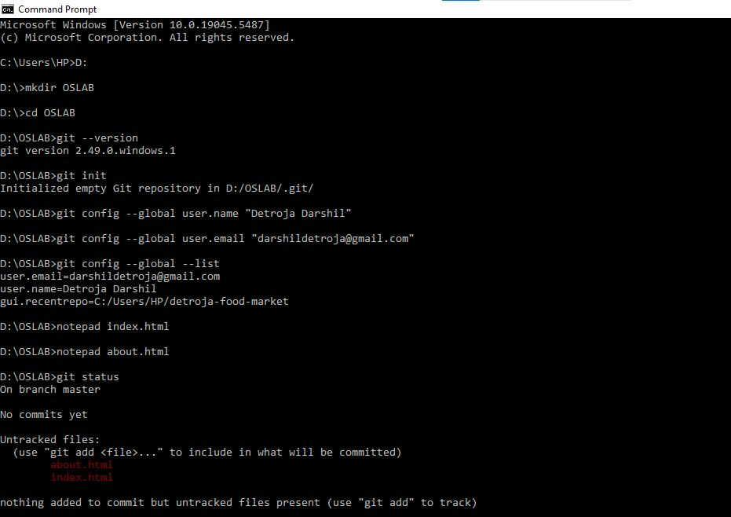
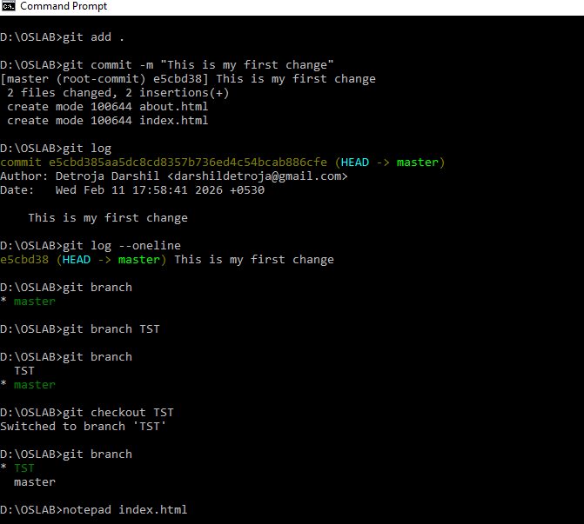

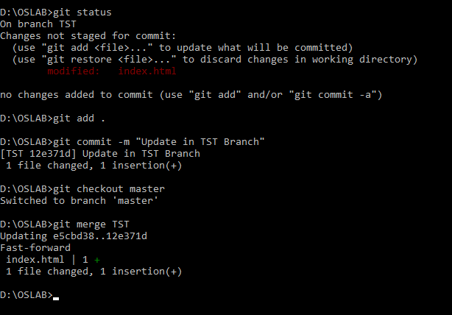

Experiment 3

Create a GitHub/GitLab repository and upload sample code.

Microsoft Windows [Version 10.0.19045.5487]
(c) Microsoft Corporation. All rights reserved.
C:\Users\fl>D:
D:\>mkdir GitDemo D:\>cd GitDemo
D:\GitDemo>git init
Initialized empty Git repository in D:/GitDemo/.git/ D:\GitDemo>notepad index.html
D:\GitDemo>git status On branch master
o commits yet Untracked files:
(use "git add <file>..." to include in what will be committed) index.html
nothing added to commit but untracked files present (use "git add" to track) D:\GitDemo>git add .
D:\GitDemo>git commit -m "First commit" [master (root-commit) 6f59051] First commit
1 file changed, 1 insertion(+) create mode 100644 index.html
D:\GitDemo>git remote add origin https://github.com/PrinceJadav01/6EC1.git D:\GitDemo>git remote -v
origin https://github.com/PrinceJadav016EC1.git (fetch) origin https://github.com/PrinceJadav01/6EC1.git (push)
D:\GitDemo>git branch
- master
D:\GitDemo>git push -u origin master Enumerating objects: 3, done.
Counting objects: 100% (3/3), done.
Writing objects: 100% (3/3), 236 bytes | 78.00 KiB/s, done. Total 3 (delta 0), reused 0 (delta 0), pack-reused 0 (from 0) To https://github.com/PrinceJadav01/6EC1.git
  - [new branch] master -> master
branch 'master' set up to track 'origin/master'.

D:\GitDemo>git branch
- master

D:\GitDemo>git branch TST
D:\GitDemo>git checkout TST Switched to branch 'TST'
D:\GitDemo>notepad xyz.html D:\GitDemo>notepad abc.html D:\GitDemo>git add .
D:\GitDemo>git commit -m "This TST branh commit" [TST c5ab360] This TST branh commit
2 files changed, 2 insertions(+) create mode 100644 abc.html create mode 100644 xyz.html

D:\GitDemo>git push origin TST Enumerating objects: 5, done. Counting objects: 100% (5/5), done. Delta compression using up to 4 threads Compressing objects: 100% (2/2), done.
Writing objects: 100% (4/4), 372 bytes | 74.00 KiB/s, done. Total 4 (delta 0), reused 0 (delta 0), pack-reused 0 (from 0) remote:
remote: Create a pull request for 'TST' on Gitub by visiting: remote: https://github.com/Darshil-Detroja/6EC1/pull/new/TST remote:
To https://github.com/PrinceJadav01/6EC1.git
* [new branch] TST -> TST
D:\GitDemo>git checkout master Switched to branch 'master'
Your branch is up to date with 'origin/master'.
D:\GitDemo>git merge TST Updating 6f59051..c5ab360 Fast-forward
abc.html | 1 + xyz.html | 1 +
2 files changed, 2 insertions(+) create mode 100644 abc.html create mode 100644 xyz.html

D:\GitDemo>git push
Total 0 (delta 0), reused 0 (delta 0), pack-reused 0 (from 0) To https://github.com/PrinceJadav01/6EC1.git
6f59051..c5ab360 master -> master
D:\GitDemo>git pull Already up to date.

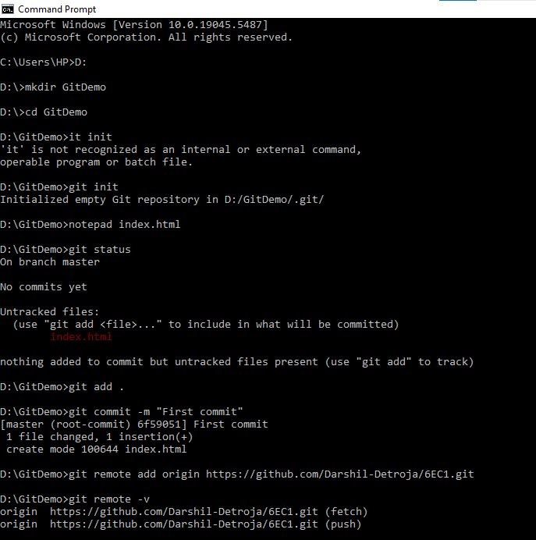

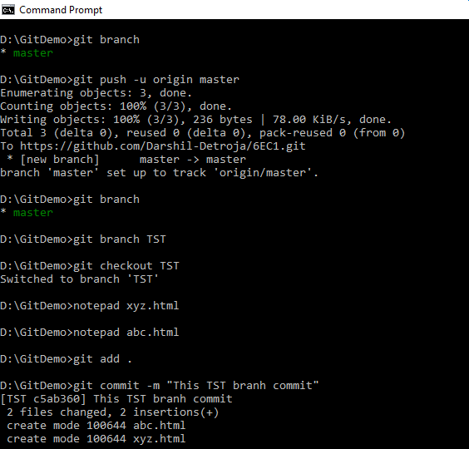
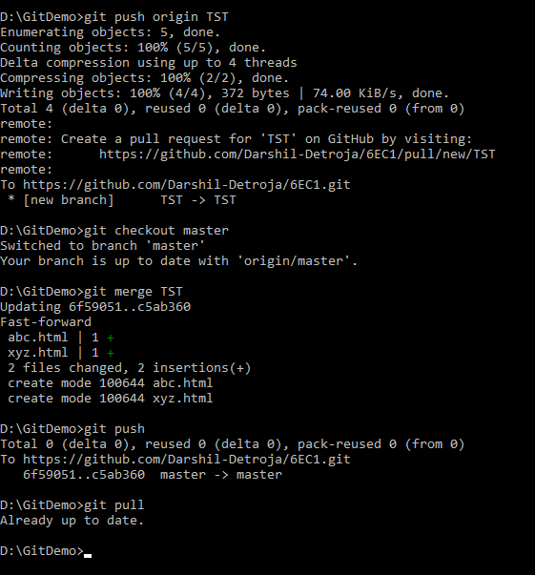

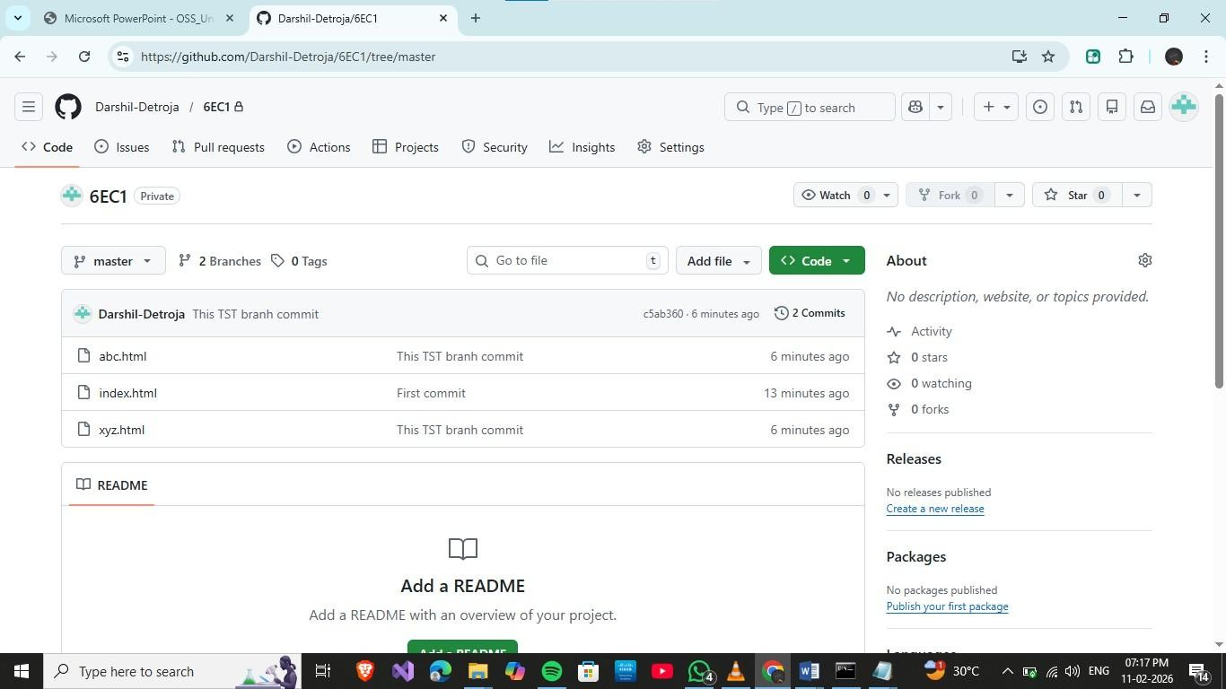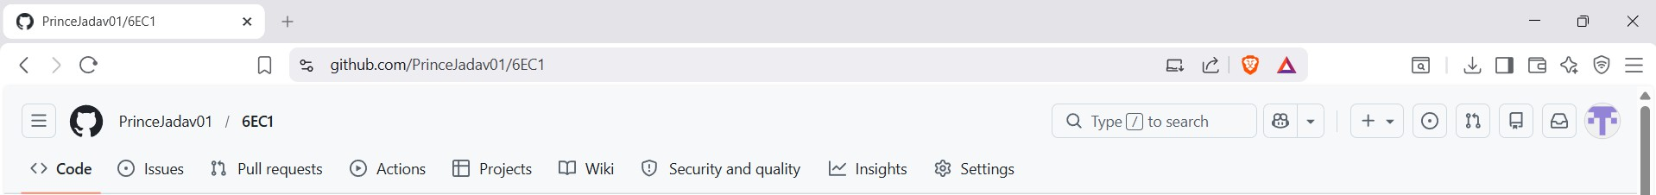
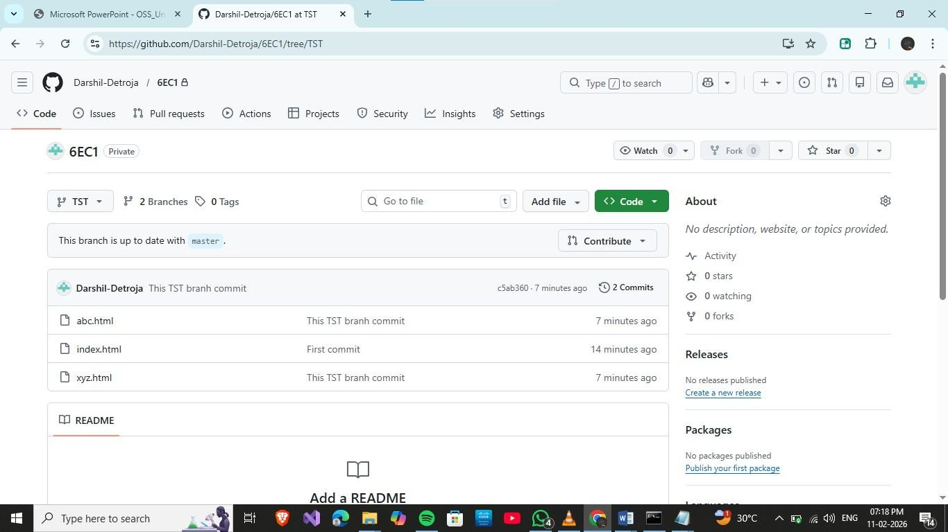


Experiment 4

AIM: Use npm / yarn / pip to install and manage packages Source Code :
//Step 1: Check Installation node -v
npm -v

// Step 2: Create ew npm Project mkdir npm-lab
cd npm-lab npm init -y
E:\OST\npm-lab\package.json:
{
"name": "npm-lab",
"version": "1.0.0",
"main": "index.js", "scripts": {
"test": "echo \"Error: no test specified\" fifi exit 1"
},
"keywords": [],
"author": "",
"license": "ISC",
"description": ""
}
// Step 3: Install Required Packages
npm install express // Install Express (Server Framework) npm install axios // Install Axios (TTP Client)
npm install nodemon --save-dev // Install odemon (Development Dependency) npm list

// Step 4: Create Web Server (index.js) const express = require("express"); const axios = require("axios");
const app = express(); app.get("/", (req, res) => { res.send("ello Open Source Įab");
});

// JSO Route

app.get("/api/info", (req, res) => {

res.json({ name: "PM Įab",
subject: "Open Source Technology", semester: "BE 6th Sem"
});

});

// Axios Demo Route

app.get("/api/user", async (req, res) => {

const response = await axios.get("https://jsonplaceholder.typicode.com/users/1"); res.json(response.data);
});

// TMĮ File Route app.get("/html", (req, res) => {
res.sendFile(path.join( dirname, "page.html"));

});

app.listen(3000, () => {

console.log("Server running at http://localhost:3000");

});

//Step 5: Run Server (ormal Way) node index.js
Open browser: http://localhost:3000 http://localhost:3000/html http://localhost:3000/api/info http://localhost:3000/api/user

//Step 6: Add npm Scripts
Open package.json and modify scripts section:

"scripts": {
"start": "node index.js",

"dev": "nodemon index.js"
}

//Step 7: Run Using npm Script npm run start //1. ormal mode
npm run dev //2. Development mode (nodemon)

//Step 8: Delete node_modules and Reinstall Delete manually
ow reinstall:
npm install
node_modules folder recreated Dependencies installed from package.json
//Step 9: Add .gitignore File fi upload project to git (without node_modules) cd npm-lab
git init
git config --global user.name "Prince Jadav"
git config --global user.email "prince.jadav122694@marwadiuniversity.ac.in" git rm -r –-cached node_modules
git add .
git commit -m “upload project inside npm-lab” git remote -v
git push -u origin main
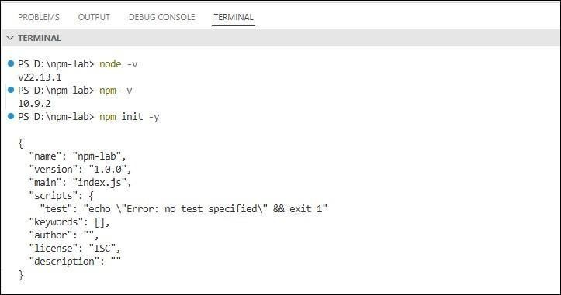

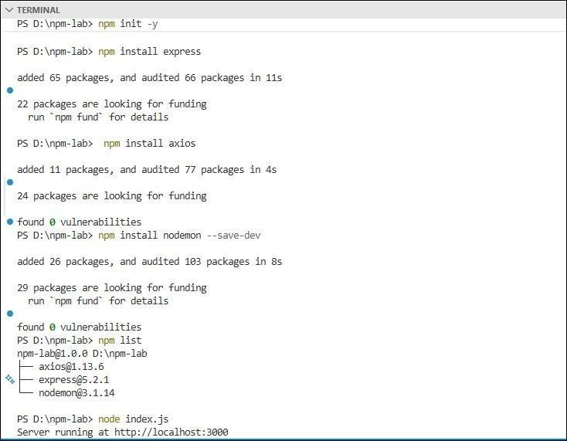
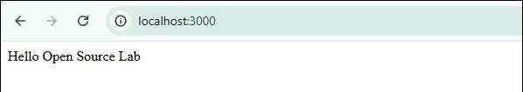
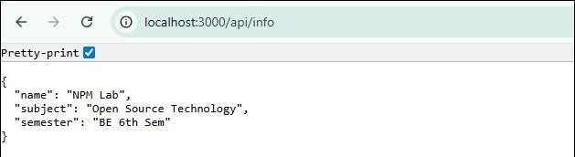

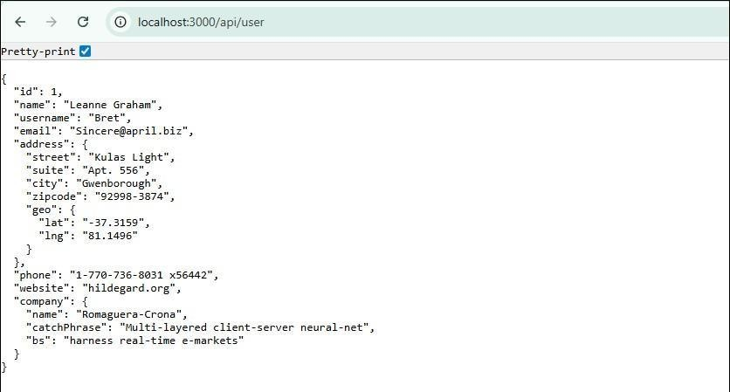
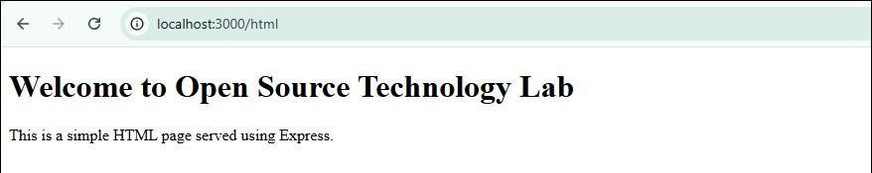
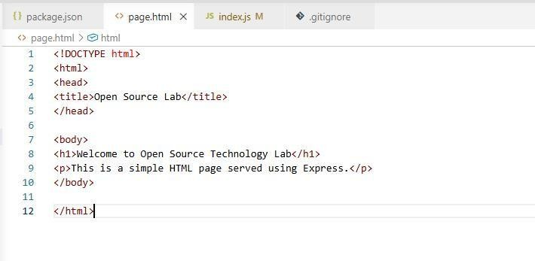

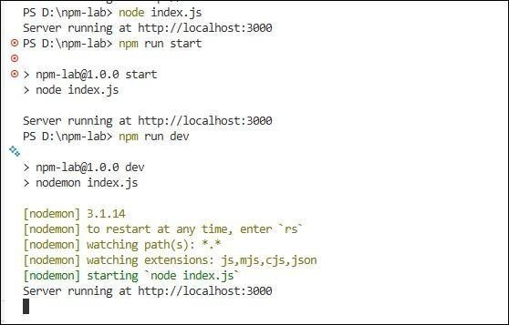

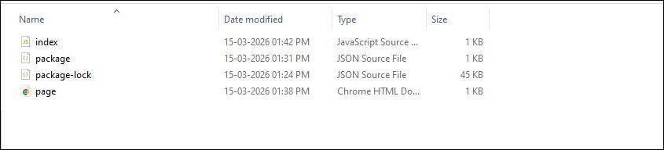
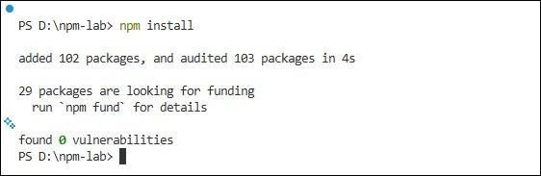

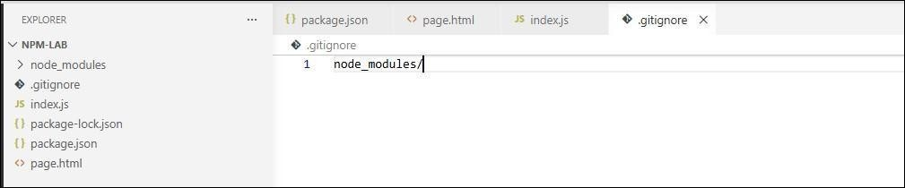
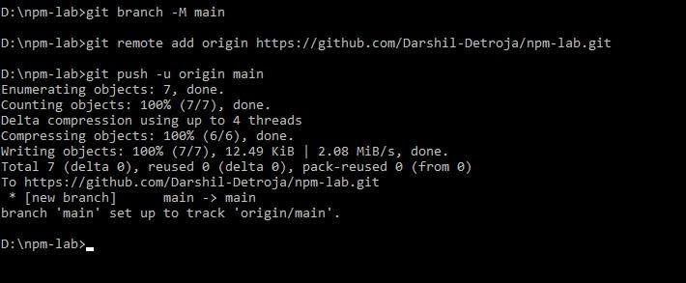
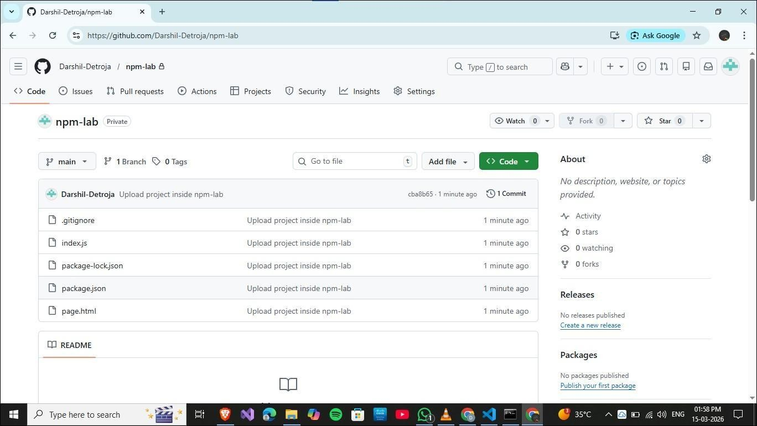
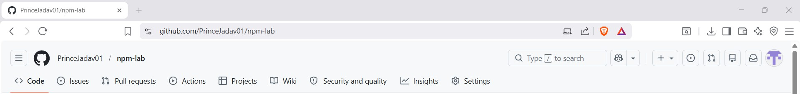

Experiment 5

AIM: Deploy a simple application using Nginx / Apache Source Code :
// step 1: create simple node.js app npm init -y
npm install express
//create index.js
node index.js //run the app

//step 2: setup nginx on windows C:\nginx [verify it] // download ginx
//config nginx.conf
//start ginx cd C:\nginx nginx -t ginx

//step 3: test reverse proxy
//open browser:
http://localhost:8080
//step 4:upload project on Gitub git init
git add .
git commit -m "Initial commit - nginx reverse proxy demo"
git remote add origin https://github.com/PrinceJadav01/nginx-demo git git branch -M main
git push -u origin main

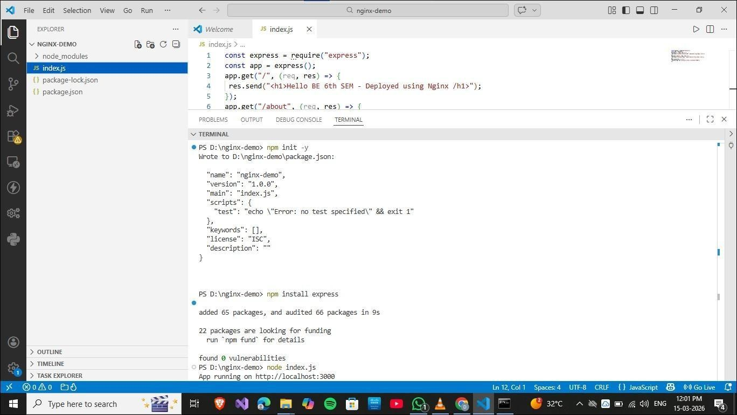
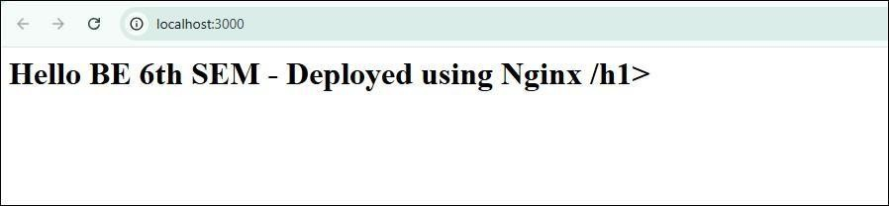


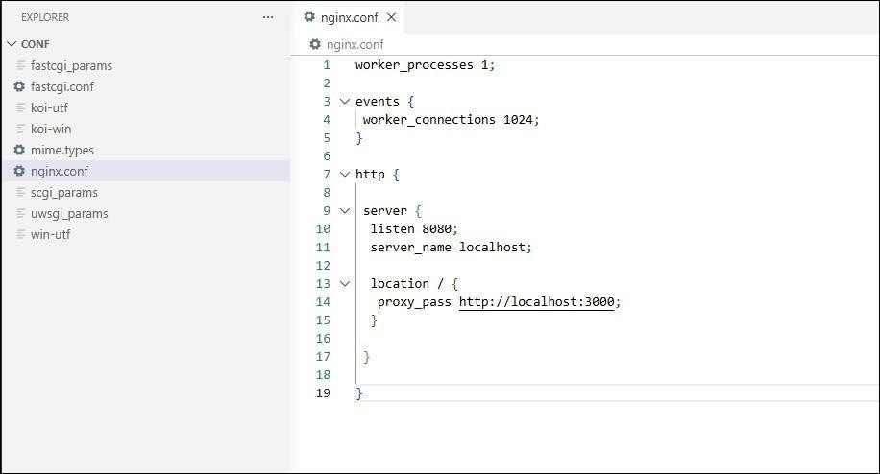
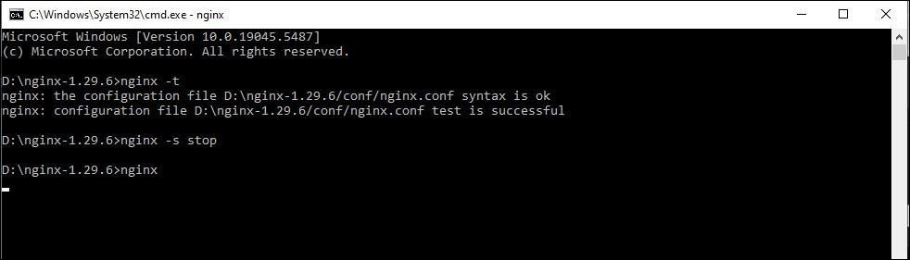
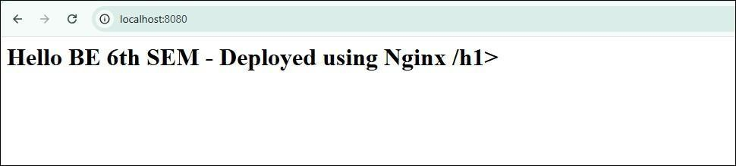

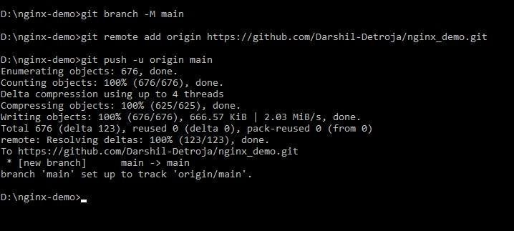
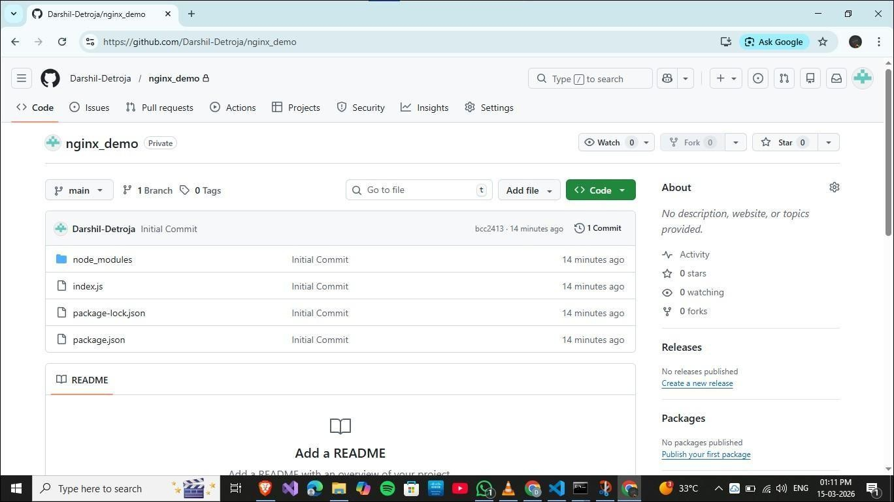
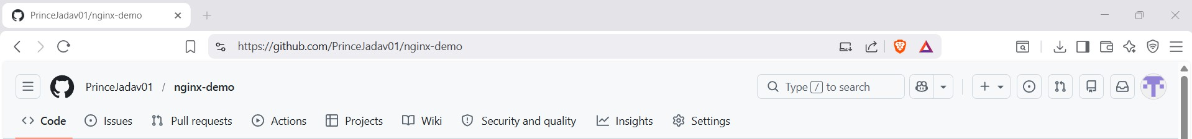

Experiment 6

AIM: Setup Nginx to handle proxy requests and load balancing Source Code :
//step 1: create a folder npm init -y
npm install express
//create server.js
node server.js //run the app
//step 2:run multiple servers
//Open 2 terminals:
//Terminal 1:
set flORT=3000 node server.js
//Terminal 2:
set flORT=3001 node server.js

//step 3:configure nginx for load balancing(Open nginx.conf and Modify http block)

//step 4:restart nginx nginx -s stop
nginx
//open fi refresh multiple times http://localhost:8080
//step 5:make server 1 slow
//step 6: do testing

//step 7: When slow server (3000) is busy for 5 seconds: It has an active connection.
So it sends new requests to:
Fast Server (3001)
//step 8:upload project on Gitub git init
git add .
git commit -m "Initial commit - GIX Load Balancing ode.js project" git remote add origin https://github.com/PrinceJadav01/load-balance git branch -M main
git push -u origin main

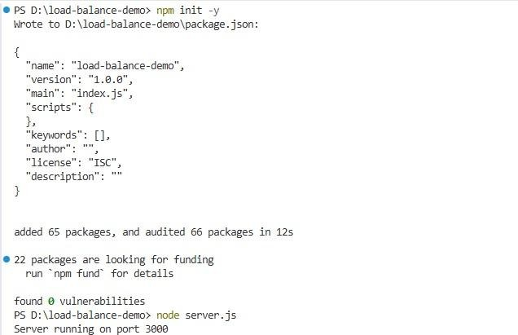

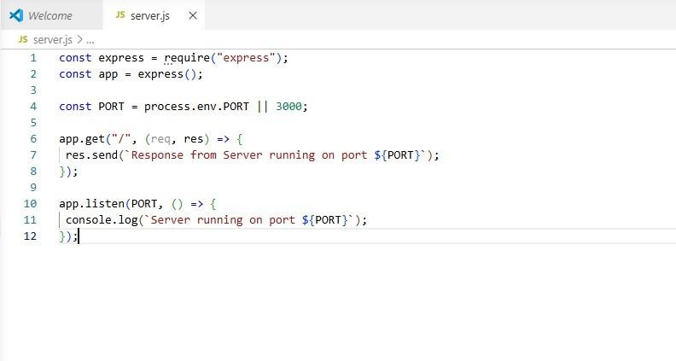

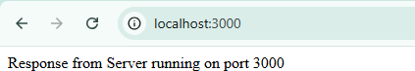

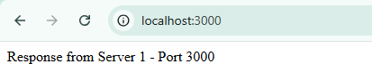

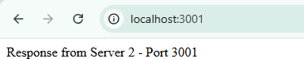

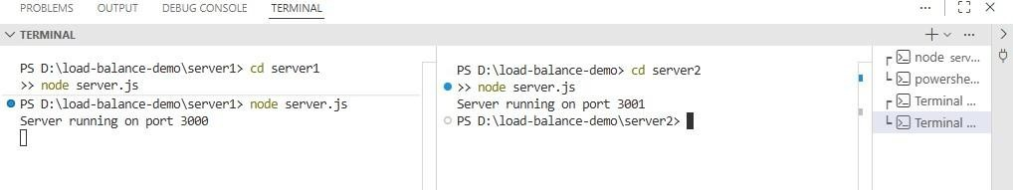

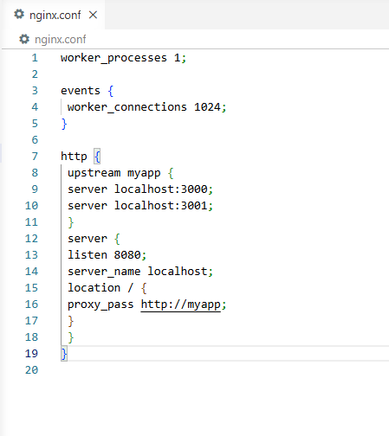
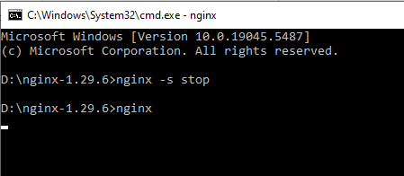

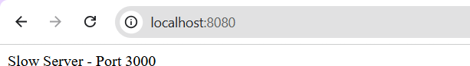

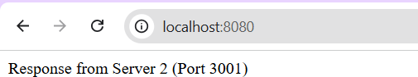

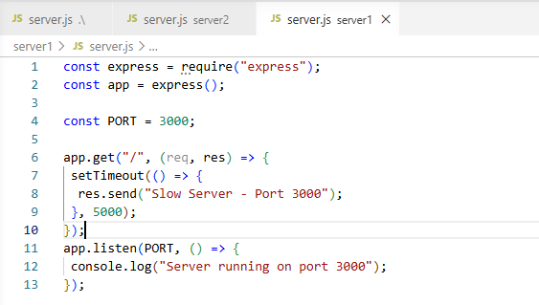
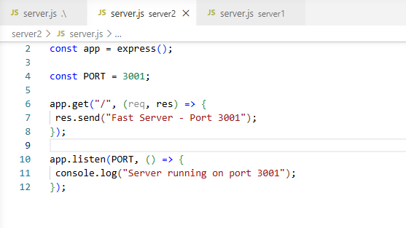

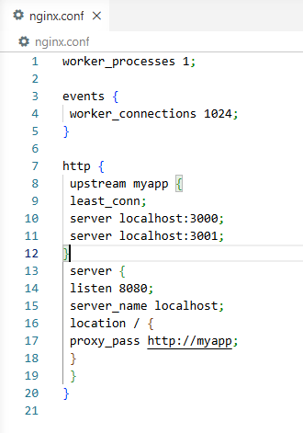

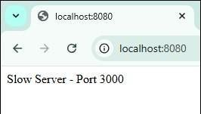
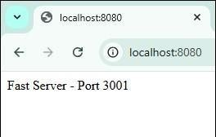

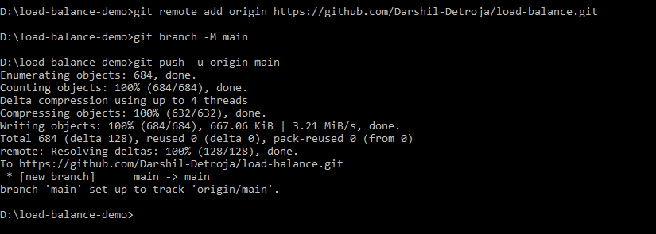

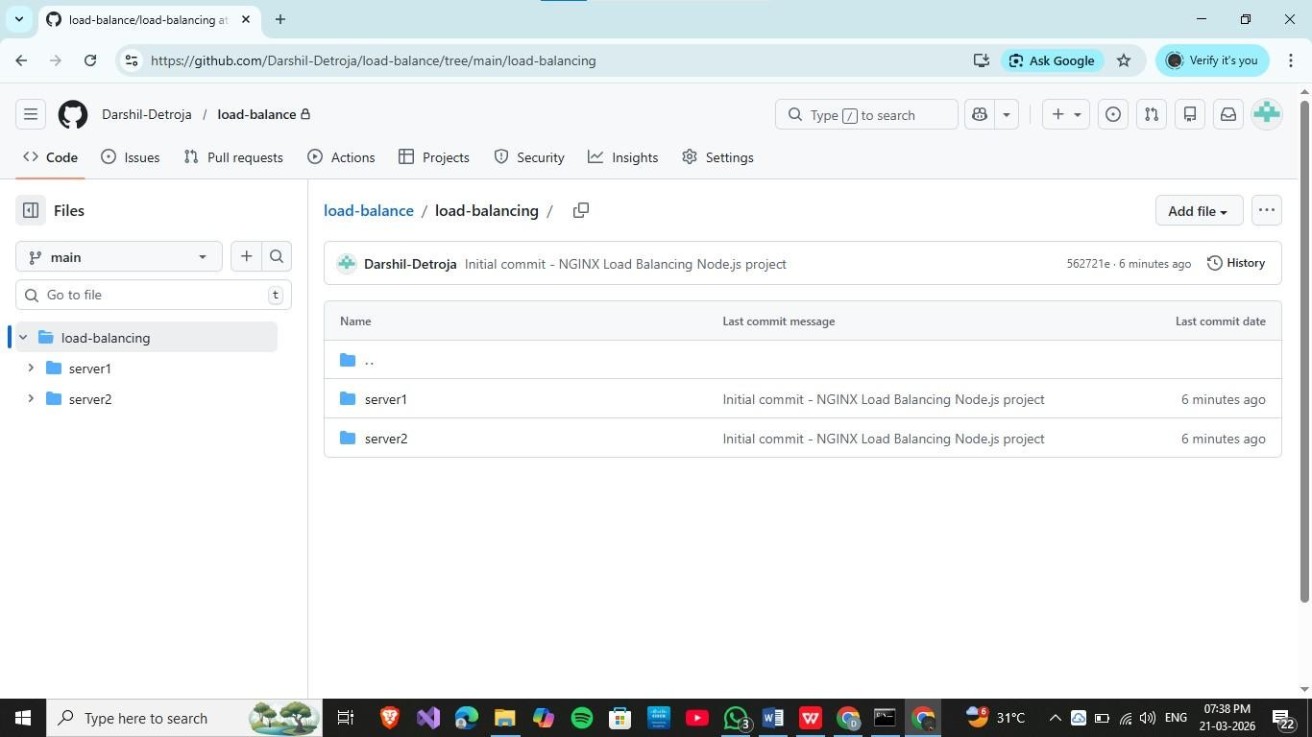
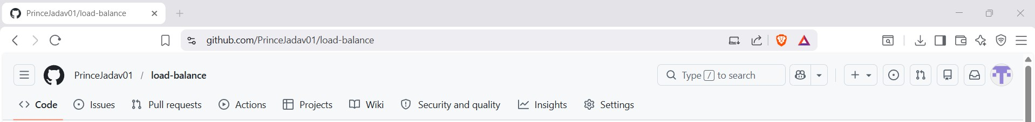

Experiment 7

AIM: Use Selenium to create browser-based tests.

// Step 1 : Install selenium and webdriver-manager pip install selenium
pip install webdriver-manager

// step 2 : Create File -> selenium_login_test.py

// step 3 : write down code in file

// step 4 : Run Test

python selenium_login_test.py

// Task: Automate YouTube Search using Selenium

// step 5 : create file -> youtube_search.py

// step 6 : write down code in file

// step 7 : Run Test python youtube_search.py

//step 8 :upload project on Gitub git init
git add .
git commit -m "Initial commit - GIX Load Balancing ode.js project"
git remote add origin https://github.com/PrinceJadav01/selenium_login_test git branch -M main
git push -u origin main

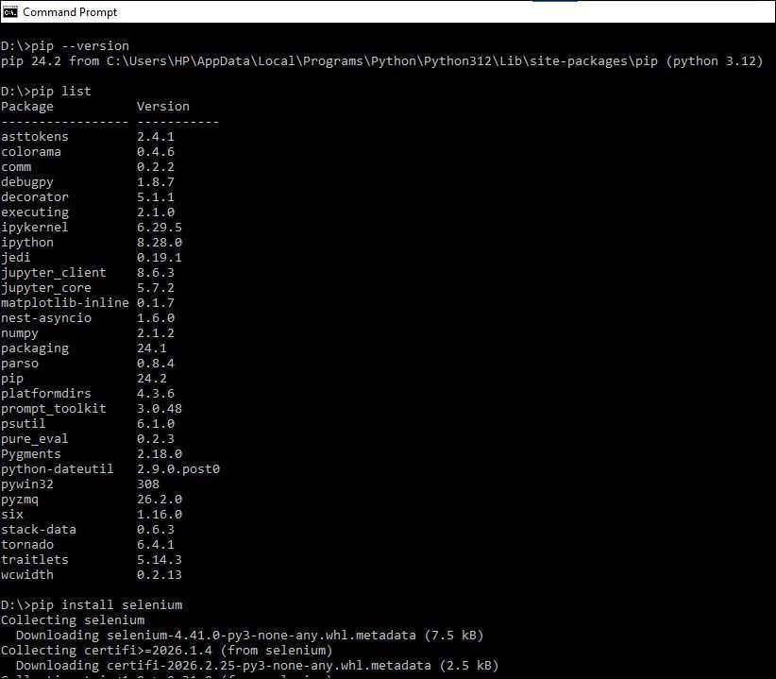
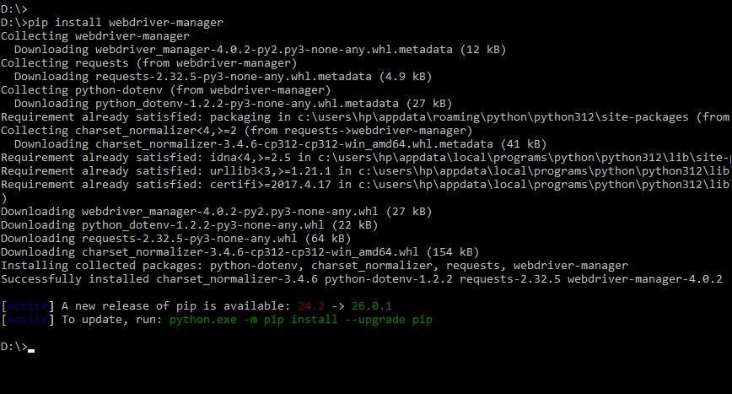

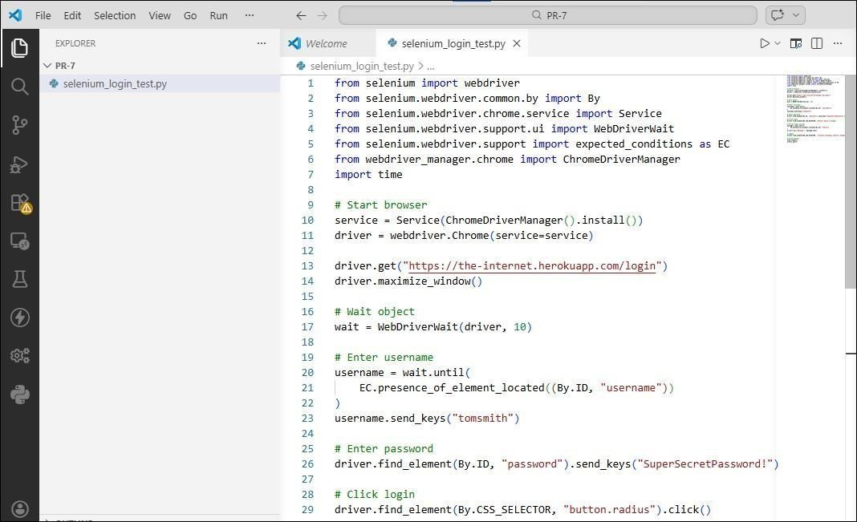
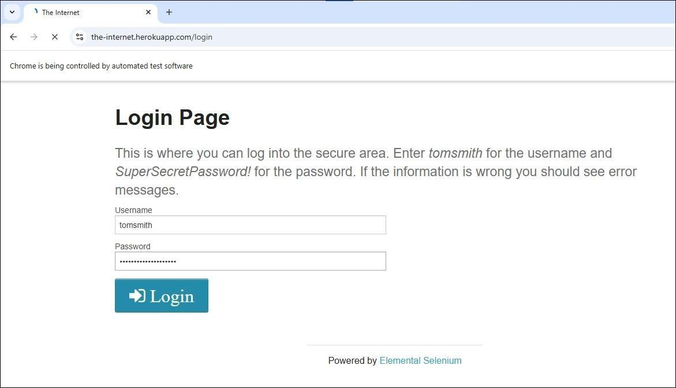

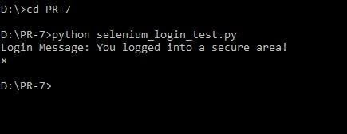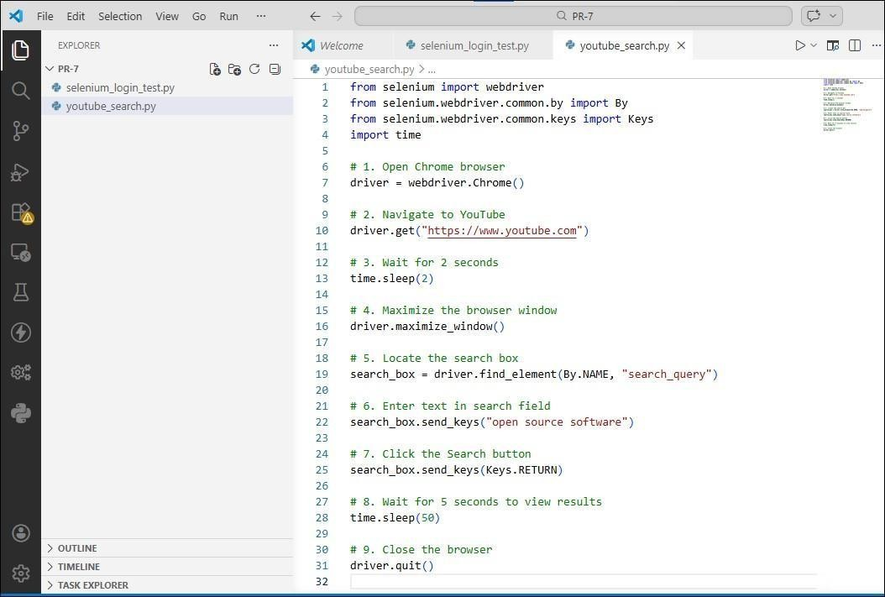

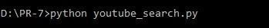

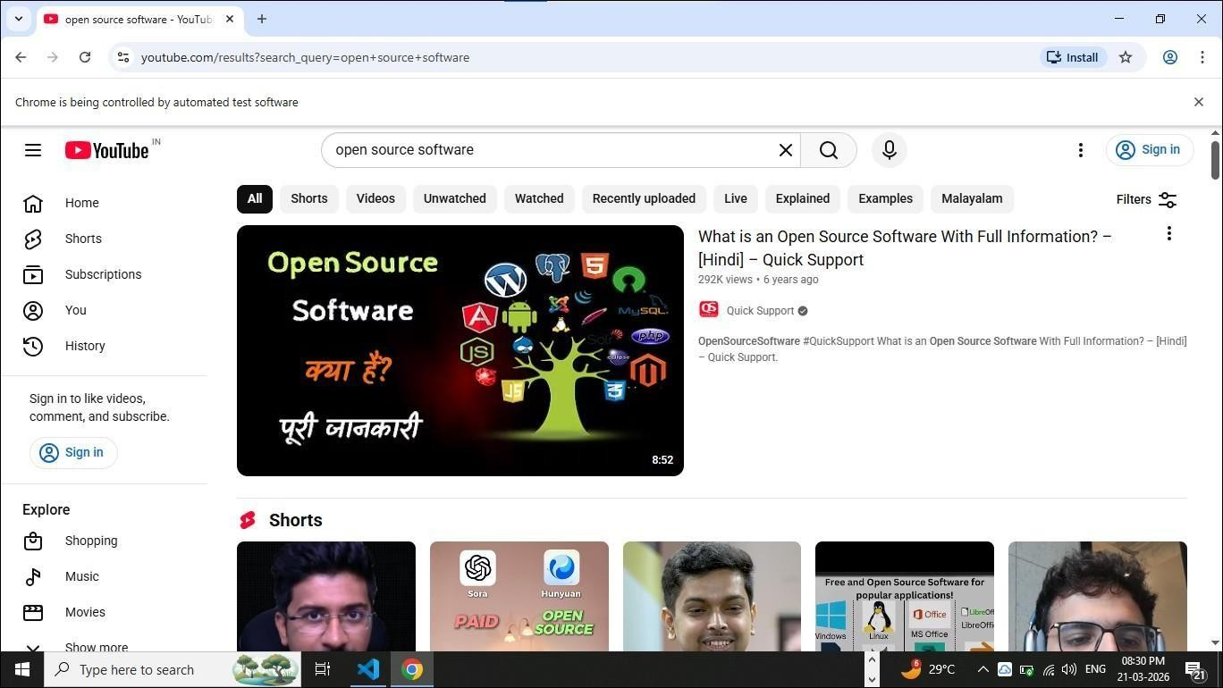

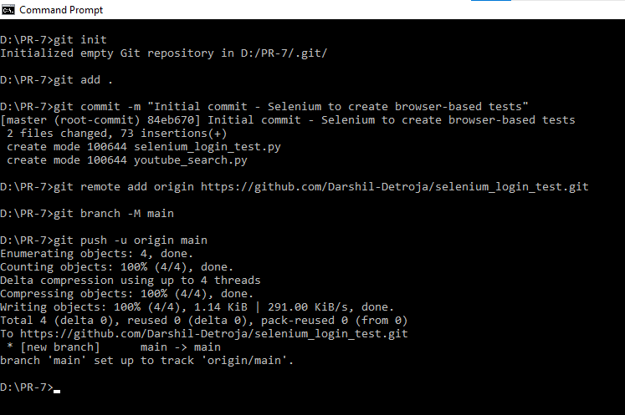

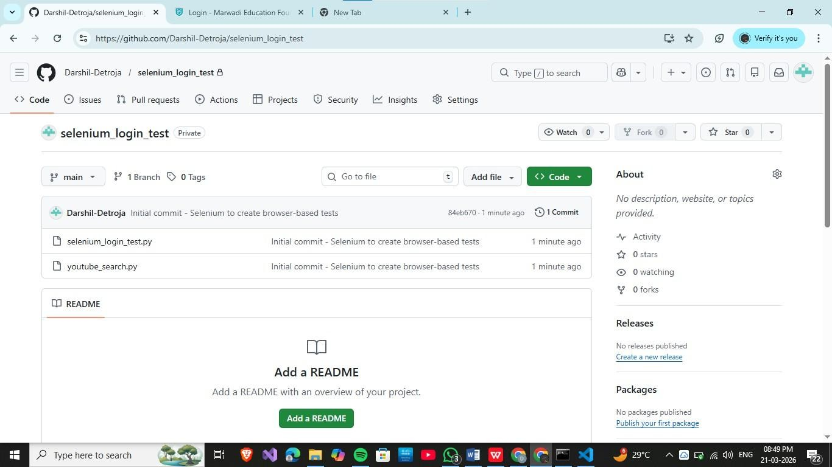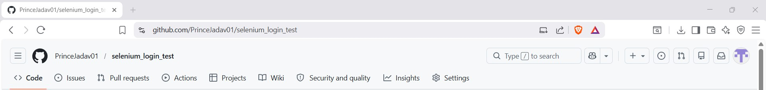

Experiment 8
AIM: Use Postman to test a sample API. Source Code :

Source Code :
//Step 1 Test AflI

Get:
URĮ: https://jsonplaceholder.typicode.com/posts flost: https://jsonplaceholder.typicode.com/posts
{
"title": "Test flost",
"body": "This is a sample post", "userId": 1
}

flut: https://jsonplaceholder.typicode.com/posts/1
{
"id": 1,
"title": "Updated Title", "body": "Updated content", "userId": 1
}

Delete: https://jsonplaceholder.typicode.com/posts/1
//Step 2 Create node.js AflI
mkdir simple-api cd simple-api npm init -y npm install express
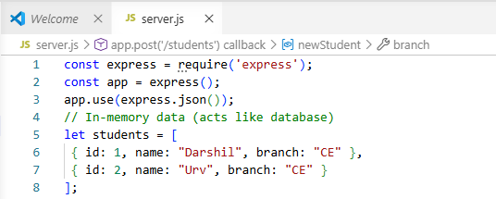
// Step 3: Create server.js file

// GET all students app.get('/students', (req, res) => { res.json(students);
});

// GET single student app.get('/students/:id', (req, res) => {
const student = students.find(s => s.id == req.params.id); res.json(student);
});

// POST - Add student app.post('/students', (req, res) => { const newStudent = {
id: students.length + 1, name: req.body.name, branch: req.body.branch
};

students.push(newStudent); res.status(201).json(newStudent);

});
// PUT - Update student app.put('/students/:id', (req, res) => {
const student = students.find(s => s.id == req.params.id); if (student) {
student.name = req.body.name; student.branch = req.body.branch; res.json(student);
} else {
res.status(404).json({ message: "Student not found" });
}
});

// DELETE - Remove student app.delete('/students/:id', (req, res) => {
students = students.filter(s => s.id != req.params.id); res.json({ message: "Student deleted" });
});

// Start server app.listen(3000, () => {
console.log("Server running on http://localhost:3000");
});

// Step 4: Run server ode server.js
Step 5 flrocedure TEST using postman

- GetAll:

Type: Get

URL : http://localhost:3000/students Check response
- flost:

Type: flost

URL: http://localhost:3000/students Body:
{

"name": "Vinay,

"branch": "MBBS"

}

Check response and Send Get request to see new data inserted

- flut request:

Type: flUT

URL : http://localhost:3000/students/2 Body:
{
"name": "Urv Updated", "branch": "CE"
}

Check response

Send Get request to see updated data

- Delete request: Type: DELETE

URL : http://localhost:3000/students/3 Check response
Send Get request to see updated data Step 6:upload project on git
git init git add .
git commit -m "Initial commit -ode.js AflI project"

git remote add origin https://github.com/PrinceJadav01/OST-
git branch -M main

git push -u origin main
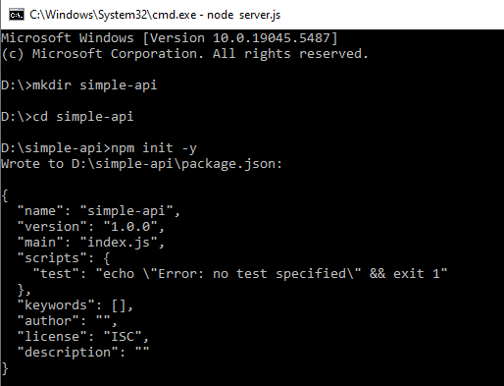
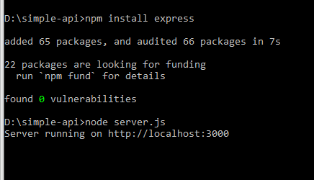

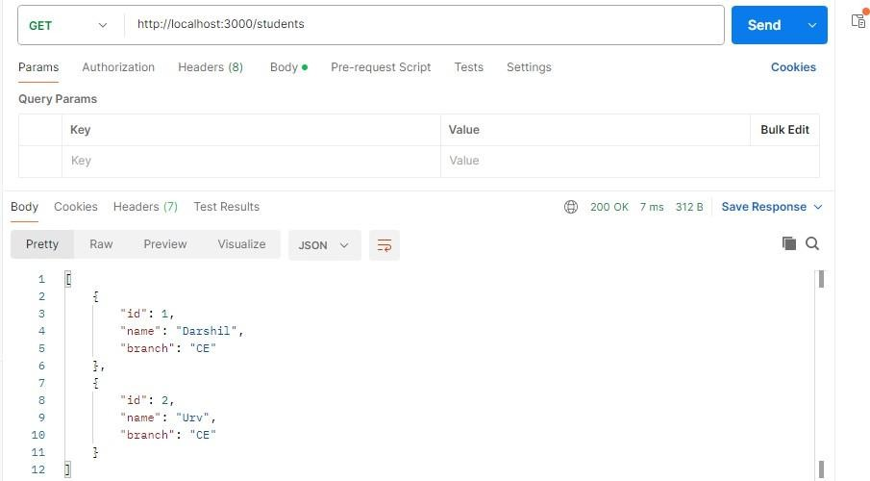
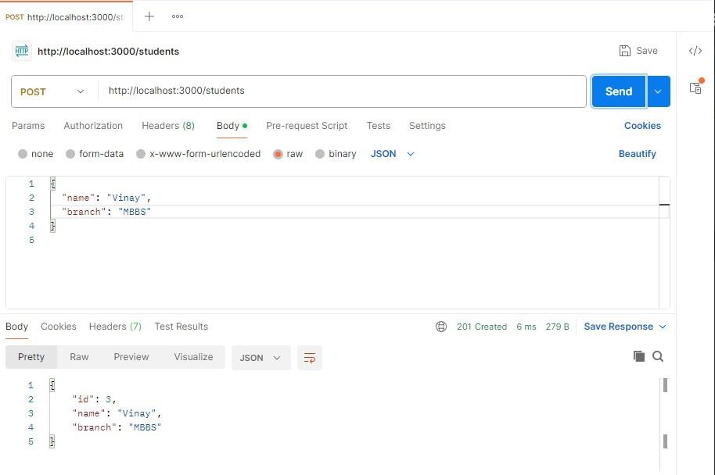

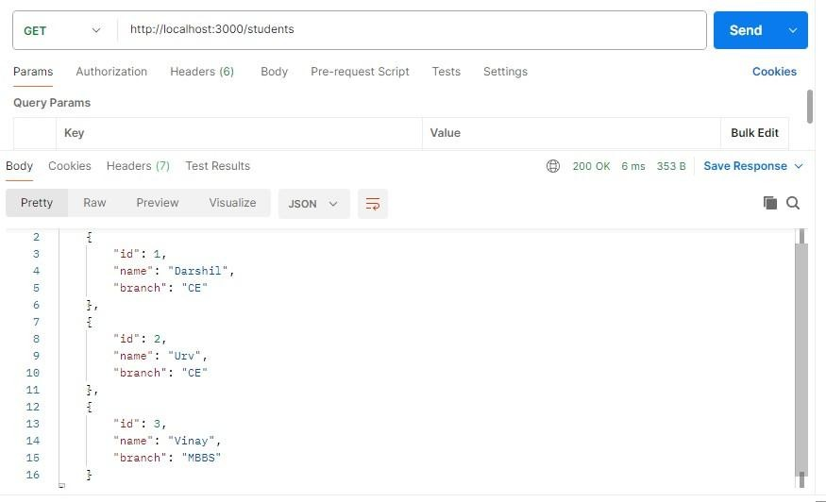
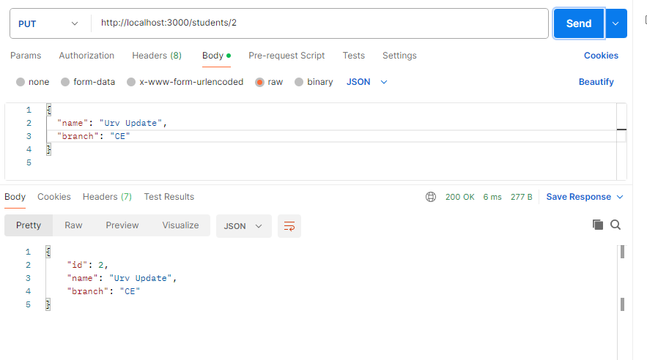

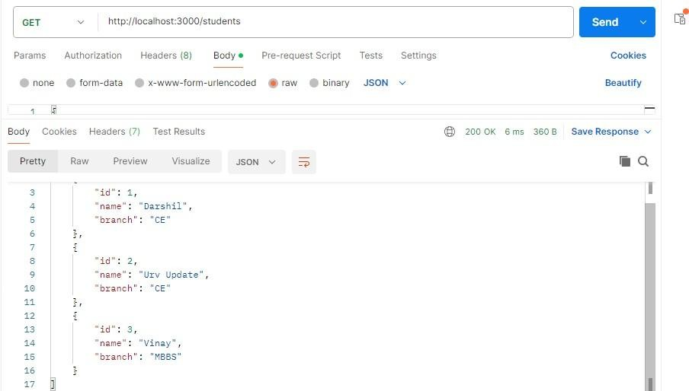
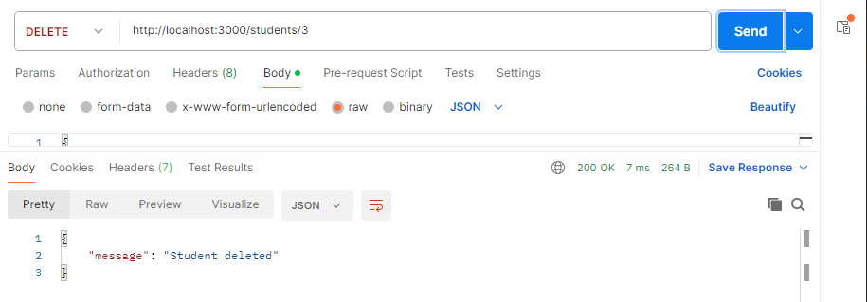
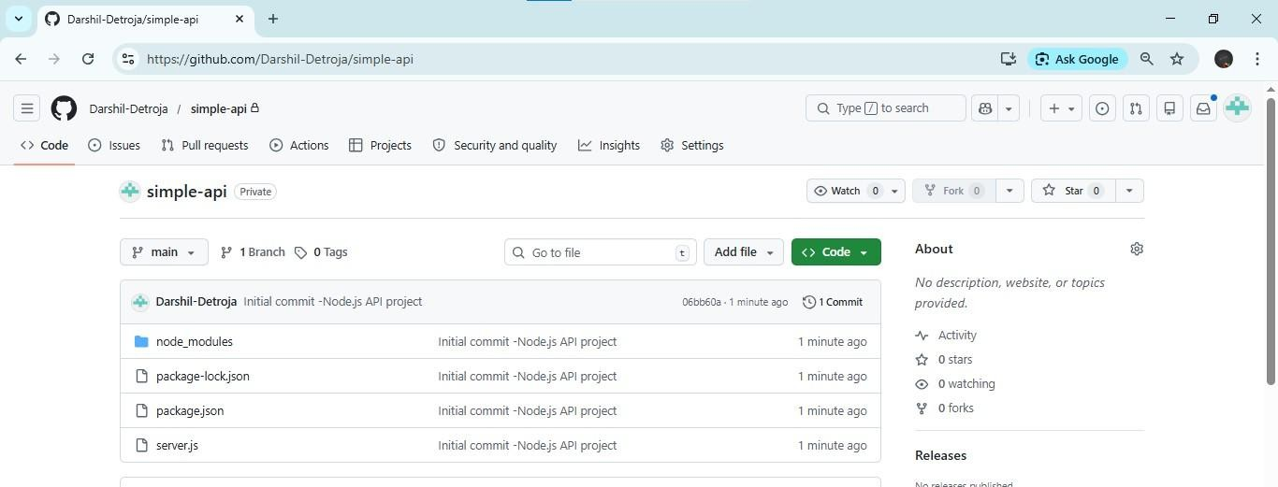
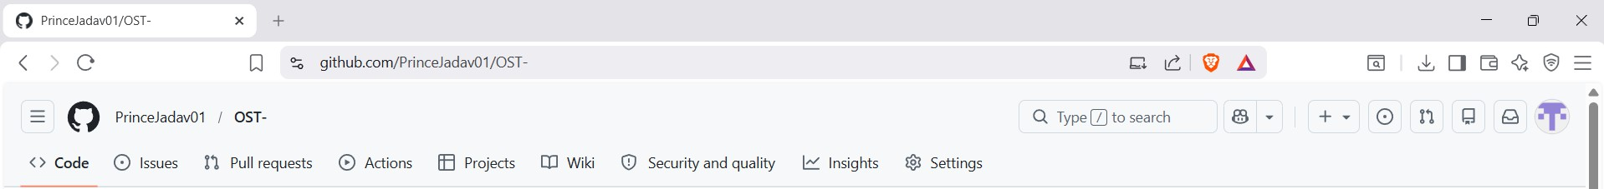

Experiment 9

AIM : Use pytest to test a Python application.

// Step 1: Install pytest pip install pytest pytest -–version

// Step 2: Create flroject Folder Mkdir flythonDemo

// Step 3: Create flython File -> pythondemo.py

// Step 4: Write Code flython Functions

// Step 5: Create Test File -> test_pythondemo.py

// Step 6: Write Code Test Cases

// Step 7: Run the Test python -m pytest -v

// step 8: task 1 -> update pythondemo.py -> add code

// step 9: task 2 -> update test_pythondemo.py -> add code
//step 8 :upload project on Gitub git init
git add .
git commit -m "Initial commit - pytest to test a flython application "
git remote add origin https://github.com/Darshil-Detroja/pytest-flythonapp.git git branch -M main
git push -u origin main

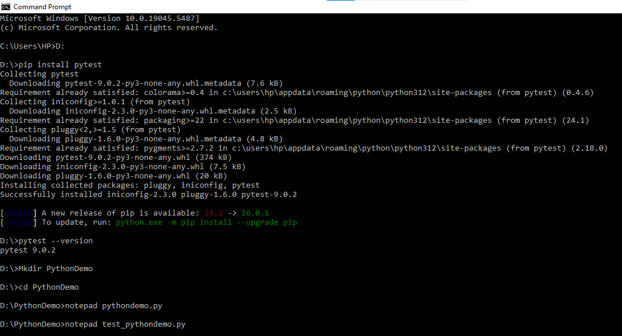

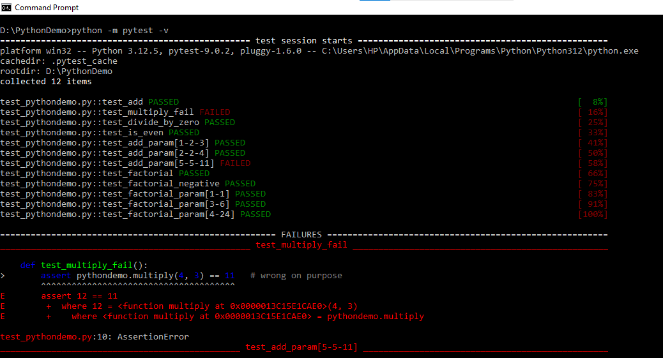

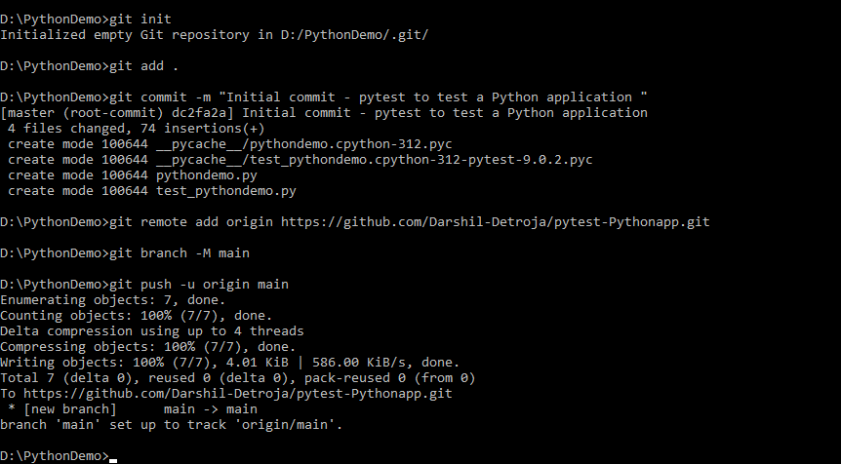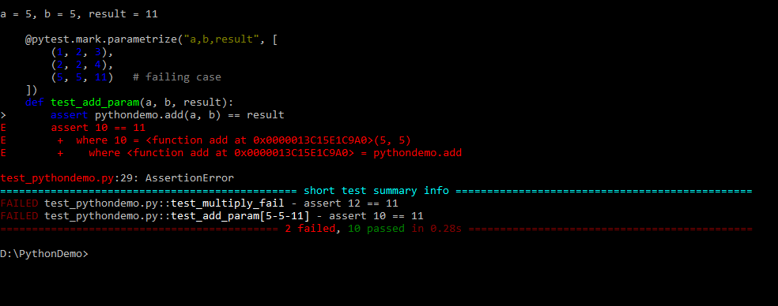

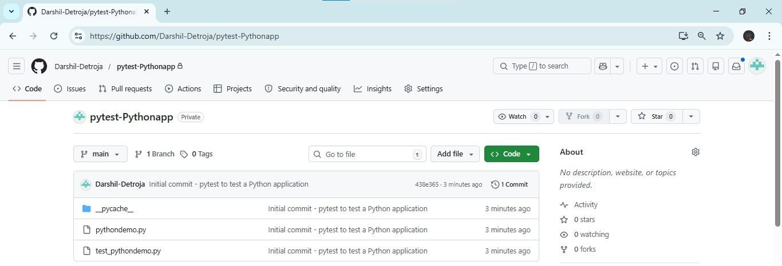


Experiment 10

Experiment – 10

Develop a Laravel / Django based web application.
D:\>mkdir django_project D:\>cd django_project
D:\django_project>django-admin startproject myproject
'django-admin' is not recognized as an internal or external command, operable program or batch file.

D:\django_project>pip show django ame: Django
Version: 5.2.12
Summary: A high-level flython web framework that encourages rapid development and clean, pragmatic design.
ome-page: https://www.djangoproject.com/ Author:
Author-email: Django Software Foundation <foundation@djangoproject.com> License-Expression: BSD-3-Clause
Location: c:\users\dell\appdata\roaming\python\python310\site-packages Requires: asgiref, sqlparse, tzdata
Required-by:

D:\django_project>python -m django startproject myproject D:\django_project>cd myproject D:\django_project\myproject>python manage.py startapp myapp
D:\django_project\myproject>python manage.py migrate Operations to perform:
Apply all migrations: admin, auth, contenttypes, sessions Running migrations:
Applying contenttypes.0001_initial... OK Applying auth.0001_initial... OK Applying admin.0001_initial... OK
Applying admin.0002_logentry_remove_auto_add... OK Applying admin.0003_logentry_add_action_flag_choices... OK Applying contenttypes.0002_remove_content_type_name... OK Applying auth.0002_alter_permission_name_max_length... OK Applying auth.0003_alter_user_email_max_length... OK Applying auth.0004_alter_user_username_opts... OK Applying auth.0005_alter_user_last_login_null... OK Applying auth.0006_require_contenttypes_0002... OK Applying auth.0007_alter_validators_add_error_messages... OK Applying auth.0008_alter_user_username_max_length... OK Applying auth.0009_alter_user_last_name_max_length... OK Applying auth.0010_alter_group_name_max_length... OK Applying auth.0011_update_proxy_permissions... OK
Applying auth.0012_alter_user_first_name_max_length... OK Applying sessions.0001_initial... OK
D:\django_project\myproject>python manage.py createsuperuser Username (leave blank to use 'dell'): pinak016
Email address: pinak@gmail.com
flassword:

flassword (again):
This password is too common.
Bypass password validation and create user anywayo [y/]: y Superuser created successfully.

D:\django_project\myproject>python manage.py runserver Watching for file changes with StatReloader flerforming system checks...

System check identified no issues (0 silenced). April 07, 2026 - 08:30:16
Django version 5.2.12, using settings 'myproject.settings' Starting development server at http://127.0.0.1:8000/ Quit the server with CTRL-BREAK.

WARIG: This is a development server. Do not use it in a production setting. Use a production WSGI or ASGI server instead.
For more information on production servers see: https://docs.djangoproject.com/en/5.2/howto/deployment/ [07/Apr/2026 08:30:32] "GET / TTfl/1.1" 200 12068
ot Found: /favicon.ico
[07/Apr/2026 08:30:32] "GET /favicon.ico TTfl/1.1" 404 2211
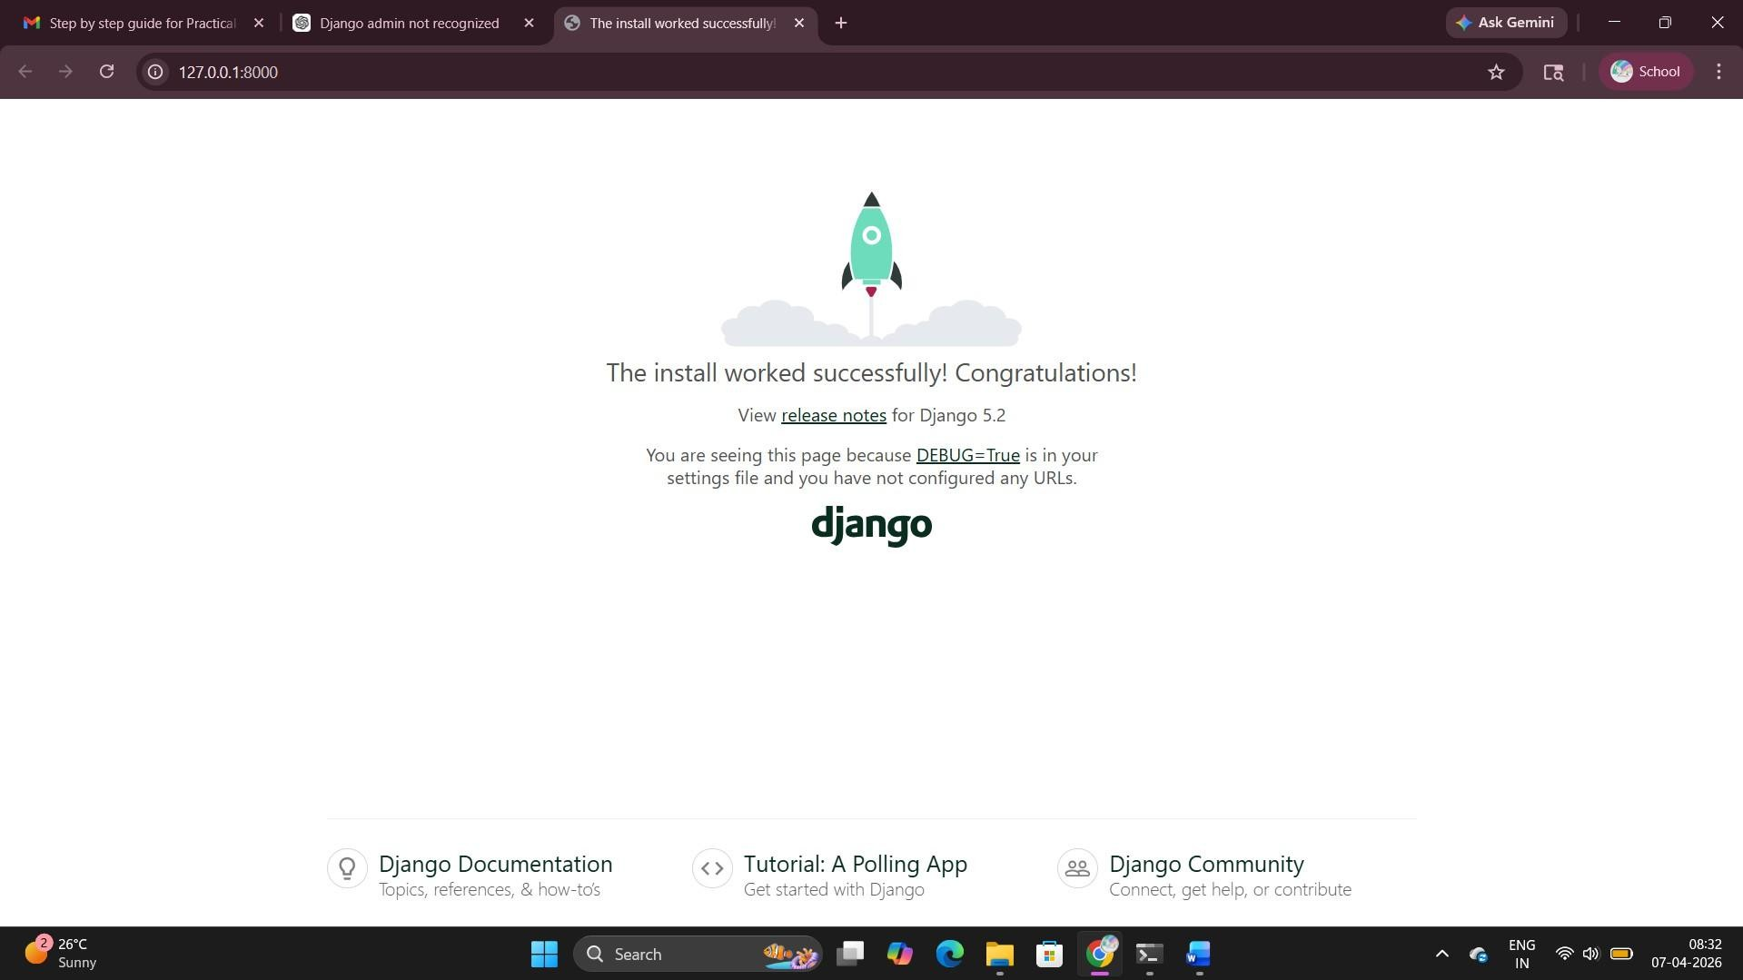

Settings.py

ISTALLED_AflflS = [
'django.contrib.admin', 'django.contrib.auth', 'django.contrib.contenttypes', 'django.contrib.sessions', 'django.contrib.messages', 'django.contrib.staticfiles', 'myapp', your app
]

Myapp/views.py
from django.shortcuts import render Create your views here.
from django.http import ttpResponse def home(request):
return ttpResponse("ello from flinak and Aarav ")

Myapp/urls.py
from django.urls import path from . import views urlpatterns = [
path('', views.home),
]

Myproject/urls.py
from django.contrib import admin from django.urls import path, include urlpatterns = [
path('', include('myapp.urls')), path('admin/', admin.site.urls),
]

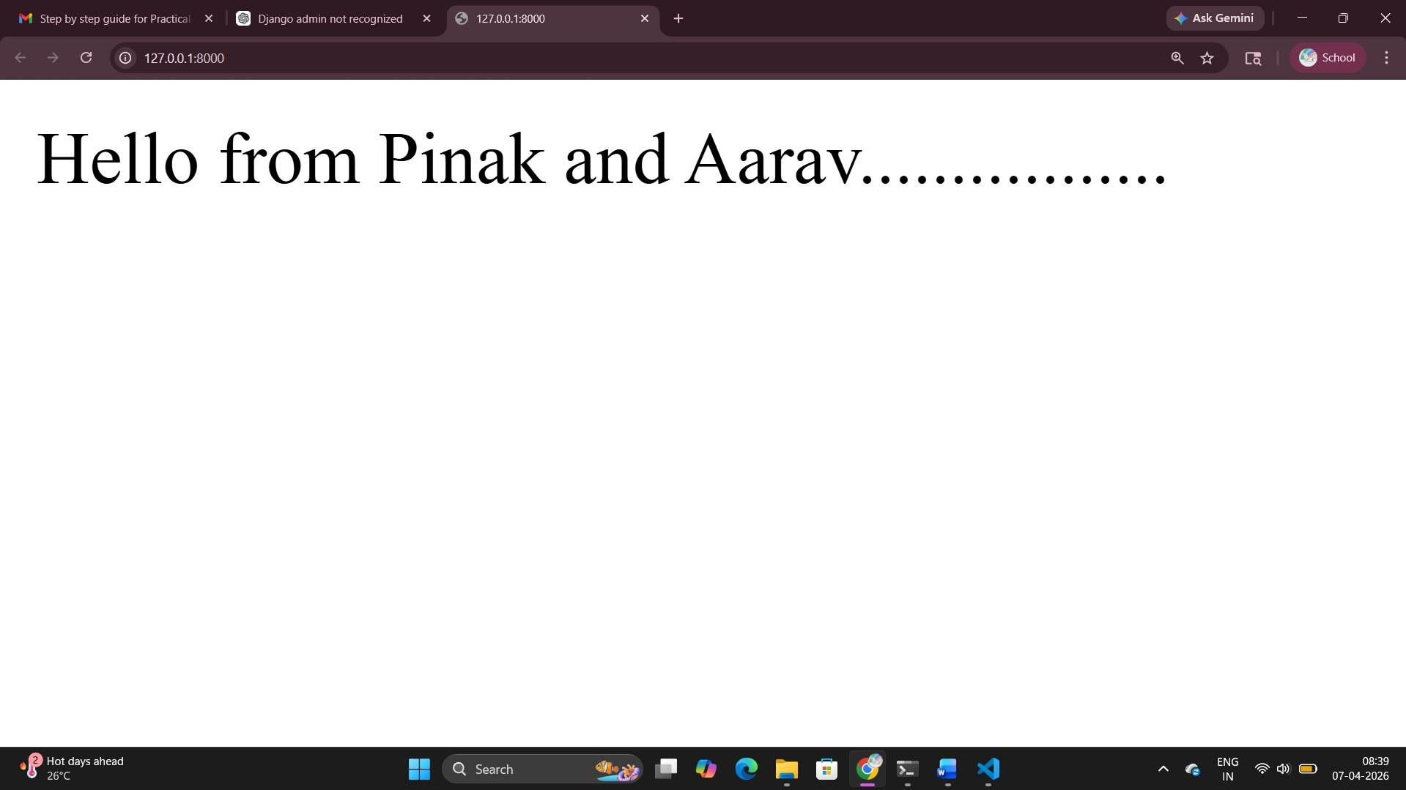

Home.html
<!DOCTYflE html>
<html lang="en">
<head>
<meta charset="UTF-8">
<title>Django GUI Demo</title>

<style>
body {
font-family: Arial, sans-serif;
background: linear-gradient(to right, 74ebd5, acb6e5); margin: 0;
padding: 0;
}
.container {
width: 400px; margin: 100px auto; background: white; padding: 30px; border-radius: 10px;
box-shadow: 0px 5px 15px rgba(0,0,0,0.2); text-align: center;

}
h1 {

}

color: 2c3e50;

p {
color: 555;
margin-bottom: 20px;
}

button {
padding: 10px 20px; border: none; background: 3498db; color: white;
font-size: 16px; border-radius: 5px; cursor: pointer; transition: 0.3s;
}

button:hover { background: 2980b9;
}

message {
margin-top: 15px; font-weight: bold; color: green;
}
</style>
</head>

<body>

<div class="container">
<h1>Welcome </h1>
<p>End is the beginning </p>

<button onclick="showMessage()">Click Me</button>

<div id="message"></div>
</div>

<script>
function showMessage() {
document.getElementById("message").innerTML = "Cliked by flinak Mer ";
}
</script>

</body>
</html>

Myapp/urls.py
from django.urls import path from . import views urlpatterns = [
path('', views.home),
]

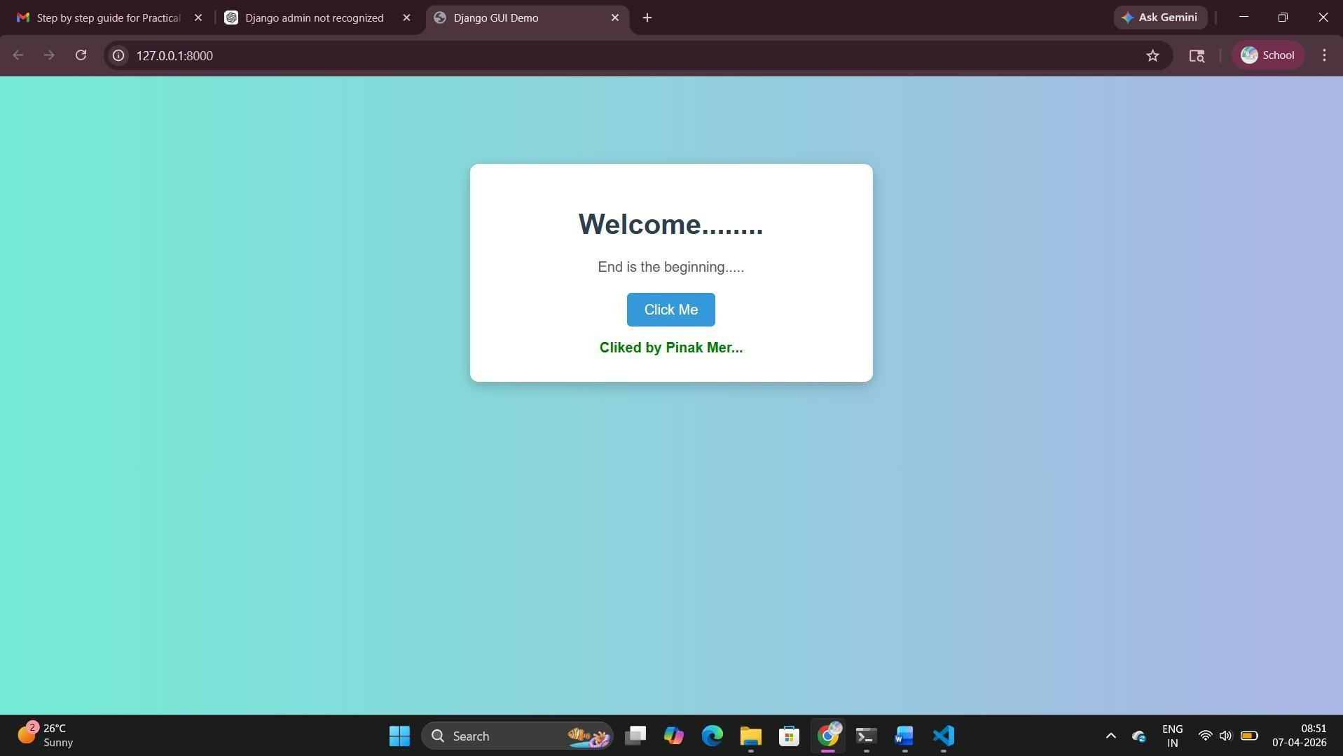

Experiment – 11

Use OWASP ZAP to check security integrity. Steps:

- Install and open OWASfl ZAfl.
- Select Quick Start → Automated Scan.
- Enter target URL: http://zero.webappsecurity.com
- Click Attack to start scanning.
- ZAfl automatically crawls the website and tests for vulnerabilities.
- After completion, go to Alerts tab to view results.
- Analyze different risk levels: igh, Medium, Low.

Conclusion:

OWASfl ZAfl was used to scan a web application and identify security vulnerabilities like missing headers and weak configurations.

